Yield Curve Regimes and Sector ETF Return Predictability
GTSF Investments Committee: Quant Sector Mentorship

1. Dataset & Sources
Two datasets were combined over January 2010–March 2026 (195 monthly observations), spanning the post-crisis recovery, 2018 hiking cycle, COVID zero-rate period, and 2022–2023 tightening cycle. U.S. Treasury yields across 10 maturities (DGS1MO through DGS30) were sourced from FRED. Sector ETF adjusted close prices for eight SPDR funds (XLK, XLF, XLE, XLU, XLV, XLI, XLP, XLY) were sourced from Yahoo Finance. Yields were resampled to month-end; ETF monthly returns were computed by summing daily log returns within each calendar month.

2. Cleaning & Preprocessing
FRED yields were forward-filled across weekends and holidays (rates don’t change when markets are closed), then both datasets were aligned on a common month-end index. Three lookahead controls were enforced: all regressors are lagged one month so month-end t yields predict month t+1 returns, the StandardScaler and PCA were fit on training data only (2010–2019) before transforming the full sample, and the Information Coefficient uses prior-period coefficients only for genuinely out-of-sample predictions.

3. Exploratory Data Analysis
EDA covered yield curve shapes at key dates, the 2Y–10Y spread over time with regime shading, 60-day rolling annualized volatility across all eight sectors, and a GARCH(1,1) extension for XLE. GARCH was applied to energy because it estimates conditional variance as a function of both yesterday’s squared shock and yesterday’s variance, producing a more responsive measure of current risk than a rolling window for assets with strong volatility clustering. Sector return correlations were also computed within each regime, showing that cross-sector correlations rise during inversion periods, reducing diversification benefits.
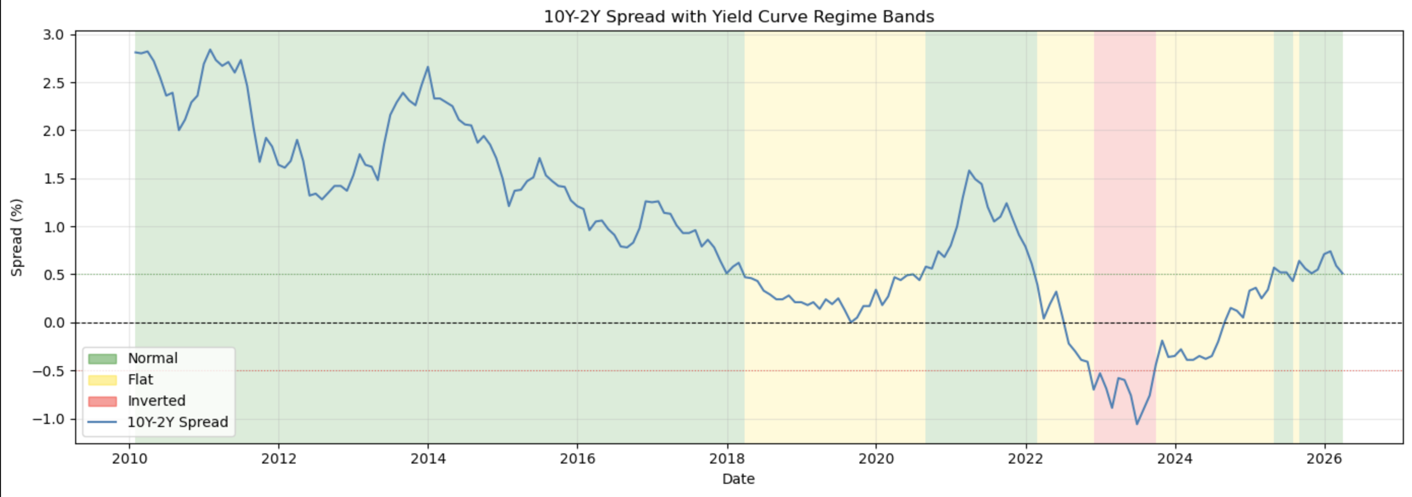
Figure 1. 10Y–2Y Treasury spread over time with Normal (green), Flat (orange), and Inverted (red) regime bands

4. Regime Classification
Each month was classified using the 10Y–2Y spread with +/-50 bps thresholds: Normal (>+50 bps): 127 months (65.1%); Flat (+/-50 bps): 58 months (29.7%); Inverted (<−50 bps): 10 months (5.1%). The inverted bucket is notably small: the 2022–2023 inversion, while deep, was brief in calendar terms. This severely limits the statistical reliability of any regime-conditional estimates for the inverted period, as ~10 observations with 4 free parameters produces near-interpolated coefficients. The +/-50 bps thresholds are defensible but somewhat arbitrary; a sensitivity analysis varying them would be a natural next step.

5. Principal Component Analysis
PCA compressed the 10 highly correlated yield maturities into three uncorrelated factors, eliminating the multicollinearity that would have distorted a direct regression. The scaler and PCA were fit on training data only (2010–2019) to prevent data leakage.
The resulting variance decomposition was: PC1 (Level) = 59.2%, PC2 (Slope) = 37.7%, PC3 (Curvature) = 2.8%, with all three components explaining 99.7% of total yield curve variation. Notably, PC2 explains substantially more variance than expected. This is probably a result of fitting the PCA exclusively on the 2010–2019 low-rate training period: when the model is then applied to the aggressive 2022–2023 hiking cycle (a structurally different environment) the slope dimension carries more weight than it would in a full-sample fit. PC1 still captures parallel rate-level shifts; PC2 captures steepening and flattening; PC3 captures independent belly movement.

6. Statistical Modeling & Evaluation
Rolling OLS. The three lagged PC scores were regressed against next-month sector returns using a 36-month rolling window, allowing the relationship to evolve across rate environments. A static model fit over the full sample would blend the near-zero rate period with the 2022–2023 hiking cycle, producing average coefficients unrepresentative of either. A static OLS trained on 2010–2019 (119 months) was evaluated on 2020–2026 (75 months), which spans COVID, zero rates, and the fastest hiking cycle in decades.
Sector | Rolling R² | In-Sample R² | OOS RMSE | OOS MAE
XLK | 0.0835 | 0.0187 | 0.0623 | 0.0515
XLF | 0.1050 | 0.0687 | 0.0645 | 0.0497
XLE | 0.0962 | 0.0350 | 0.1004 | 0.0682
XLU | 0.0532 | 0.0127 | 0.0538 | 0.0427
XLV | 0.0498 | 0.0201 | 0.0434 | 0.0363
XLI | 0.0738 | 0.0224 | 0.0591 | 0.0452
XLP | 0.0509 | 0.0107 | 0.0414 | 0.0330
XLY | 0.0748 | 0.0113 | 0.0656 | 0.0499
Table 1. Model evaluation across all 8 sector ETFs. Rolling R² uses the 36-month window over the full sample. In-Sample R², OOS RMSE, and OOS MAE are from the 2010–2019 train / 2020–2026 test split.
Regime-conditional OLS. Separate regressions within each regime show that PC2 (Slope) coefficients are negative across nearly all sectors in every regime, including cyclicals like XLF and XLE. This is counterintuitive, as a steeper curve is conventionally expected to benefit financials and cyclicals. One potential explanation is that curve steepening during this sample period often accompanied Fed pivot expectations, where defensives initially outperform. Another is that with R² values of 1–7%, the coefficients carry substantial noise.

7. Cross-Sectional Rank Model & Information Coefficient
Level-return R² is dominated by broad market beta, masking any sector rotation signal. Sectors were ranked 1–8 by forward return each month and the model re-run on those ranks, forcing it to compete purely on identifying which sectors outperform relative to each other. The Information Coefficient (IC), aka the monthly Spearman correlation between predicted and actual rankings, was computed using prior-period coefficients only, making it genuinely out-of-sample.
The result was mean IC = 0.019, t-stat = 0.58, positive in 51.9% of months. A t-statistic of 0.58 is well below the conventional threshold of 2 for statistical reliability, meaning the model does not demonstrate a significant out-of-sample sector rotation signal. In other words, once the IC is computed using only information available before each return period, the yield curve factors alone do not reliably identify which sectors will outperform in a given month. The IC’s near-zero value and the 51.9% positive rate are consistent with random guessing across an 8-sector universe.
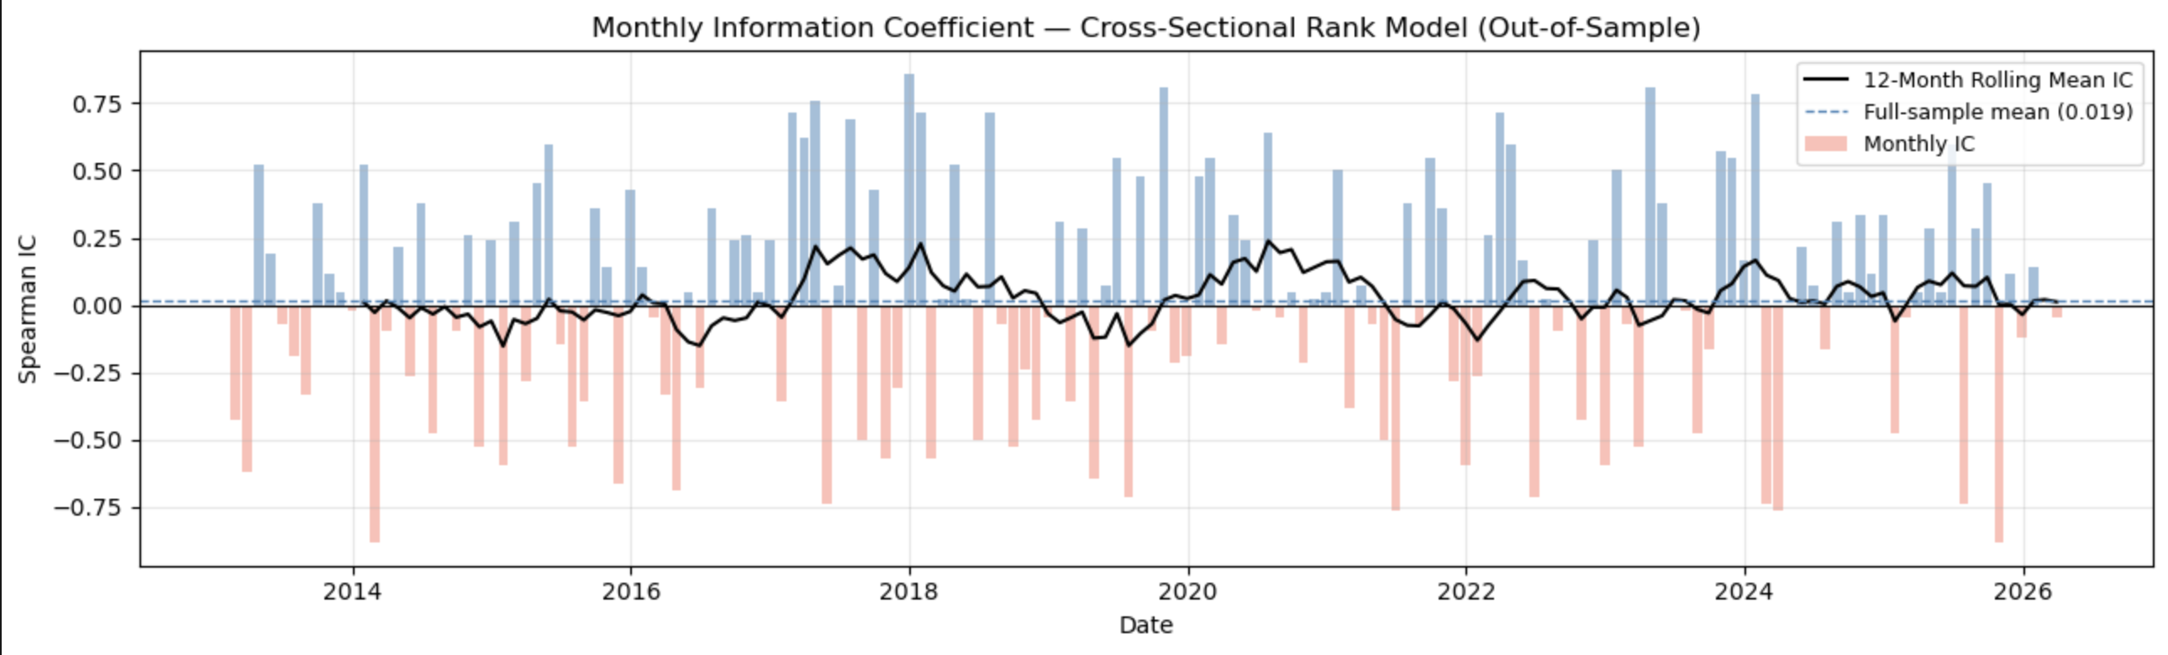
Figure 2. Monthly out-of-sample Information Coefficient (IC) with 12-month rolling mean.

8. Key Findings & Reflection
- Yield curve factors explain 1–7% of monthly sector return variation. This is modest but consistent with efficient markets, as any explanatory power above zero is meaningful. XLF shows the strongest fit (rolling R² = 10.5%, in-sample R² = 6.9%), reflecting its structural dependence on the yield spread.
- PC2 explains far more variance than typical yield curve PCA. Fitting PCA only on the 2010–2019 training period produced a PC2 (Slope) that explains 37.7% of variance rather than the typical ~7%. This is a methodological artifact of the training-period constraint and the unusual out-of-sample rate environment of 2022–2023.
- PC2 coefficient directions are counterintuitive. All sectors show negative or near-zero PC2 coefficients in the Normal regime, contrary to the expected cyclical/defensive split. This may reflect that curve steepening in this sample period coincided with conditions that did not straightforwardly benefit cyclicals, or may simply be noise given the low R² environment.
- The rank model does not produce a reliable out-of-sample rotation signal. After applying the methodologically correct out-of-sample IC computation, mean IC = 0.019 (t-stat = 0.58), which is not statistically significant. Three yield curve factors alone are insufficient to consistently identify sector rotation.
- GARCH confirms energy volatility persistence. XLE exhibits strong volatility clustering; GARCH(1,1) conditional volatility responds faster to shocks than rolling std, explaining its highest OOS RMSE (10.0%) despite reasonable rolling R² (9.6%).

Reflection: The PCA and rolling window design choices were both appropriate. PCA eliminated multicollinearity while retaining 99.7% of yield curve information, and rolling OLS captured time-varying dynamics that a static model would have averaged away. However, fitting the scaler and PCA on the training period only produced an unusual variance decomposition, a finding that I could investigate in future work by comparing train-only vs. full-sample PCA. The IC result shows that three yield curve factors, while statistically detectable in level-return regressions, do not translate into a reliable sector rotation signal once evaluated correctly out-of-sample.
Key limitations: only 10 inverted-regime observations; OOS errors 3–7× larger than average returns; IC not significant.
Next steps: extend data to the 1990s for a larger inverted sample, add credit spreads and VIX to expand the feature set, compare train-only vs. full-sample PCA, and apply regularized regression as regressors grow.

